Experiment 4 – A CLIENT –SERVER UDP PROGRAM

Aim: - To create a simple client-server communication using UDP protocol.

Steps for server: -

1. We import socket module which helps in establishing the client/server communication.
2. We specify the protocol type, UDP in our case so we use datagram.
3. We bind the localhost of server with client using bind function.
4. We receive the data from client (max 4096 bytes) and print it.
5. We send a message from the server to client using sendto function.

Steps for client: -

1. We import socket module which helps in establishing the client/server communication.
2. We specify the protocol type, UDP in our case so we use datagram.
3. We encode the message we get from server and print it in the client side.
4. We close the connection.

Code for server :-

**import** socket  
sock=socket.socket(socket.AF_INET,socket.SOCK_DGRAM)  
sock.bind((**'localhost'**,12345))  
  
**while True**:  
 data,addr=sock.recvfrom(4096)  
 print(str(data))  
 message=bytes((**'Hello this is UDP SERVER !'**).encode(**'utf-8'**))  
 sock.sendto(message,addr)

Code for Client:-

**import** socket  
c_sock=socket.socket(socket.AF_INET,socket.SOCK_DGRAM)  
  
msg=**"Hello Server, Client here !"**c_sock.sendto(msg.encode(**'utf-8'**),(**'localhost'**,12345))  
data,addr=c_sock.recvfrom(4096)  
print(**'Server Says : '**)  
print(str(data))  
c_sock.close()

Console Snapshots:-

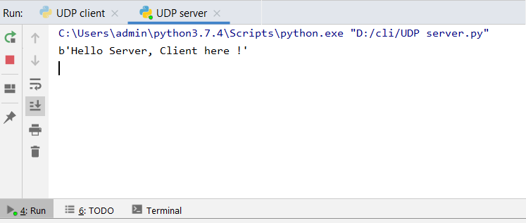1)Server Console : -

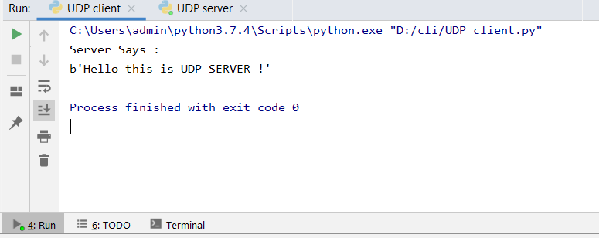2) Client Console : -

Result : - The client server connection was successfully established in UDP protocol.